---------------------------------------------------------------------

-- LAB 03

--

-- Exercise 1

---------------------------------------------------------------------

USE TSQL;

GO

---------------------------------------------------------------------

-- Task 1

--

-- Using SSMS, connect to MIA-SQL using Windows authentication (if you are connecting to an on-premises instance of SQL Server) or SQL Server authentication (if you are using SQL Azure).

--

-- In Object Explorer, expand the TSQL database and expand the Tables folder.

--

-- Take a look at the names of the tables in the Sales schema.

---------------------------------------------------------------------

---------------------------------------------------------------------

-- Detyre 1

--

1-- Nepermjet SSMS, lidhu me MIA-SQL duke perdorur Windows authentication (ne qoftese jeni duke u lidhur me nje instance lokale te SQL Server) ose SQL Server authentication (ne qoftese jeni duke perdorur SQL Azure).

2-- Ne Object Explorer, zgjero TSQL database dhe zgjero Tables folder.

--

3-- Shikoni emrat e tabelave ne skemen Sales.

---------------------------------------------------------------------

1-Double Click on ‘Connect’ button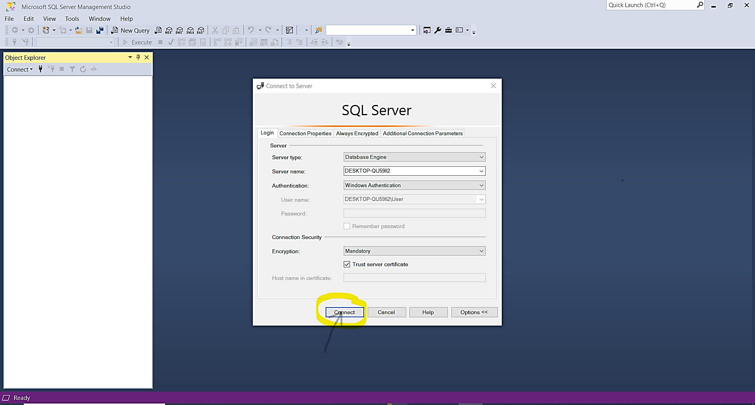

2-After ‘connecting’, the display of SQL Server Management Studio

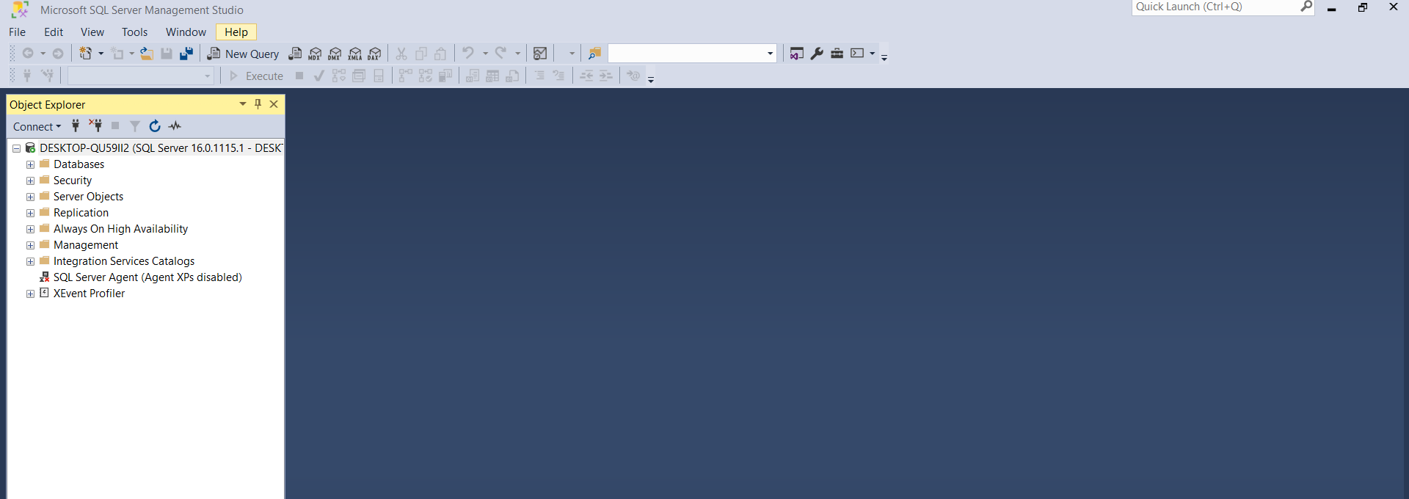

-Double on Databases or one-click on the ‘+’ in the left of databases and it will diplay:

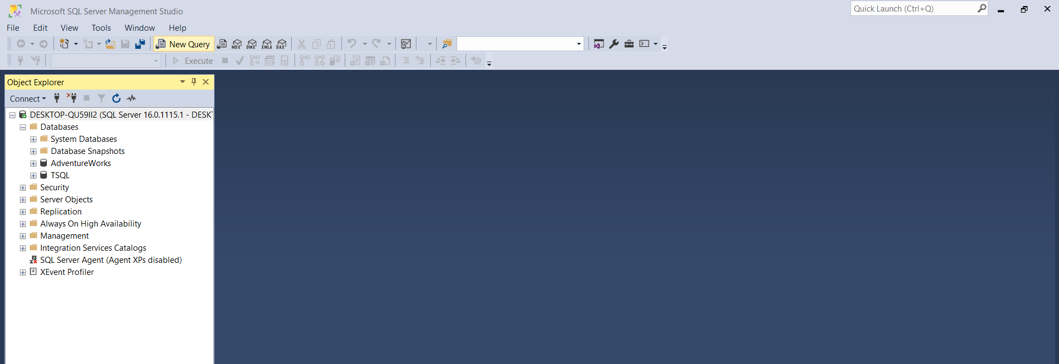

-Expand TSQL Database by click the ‘+’ on the left of TSQL Database or Double-click on TSQL Database

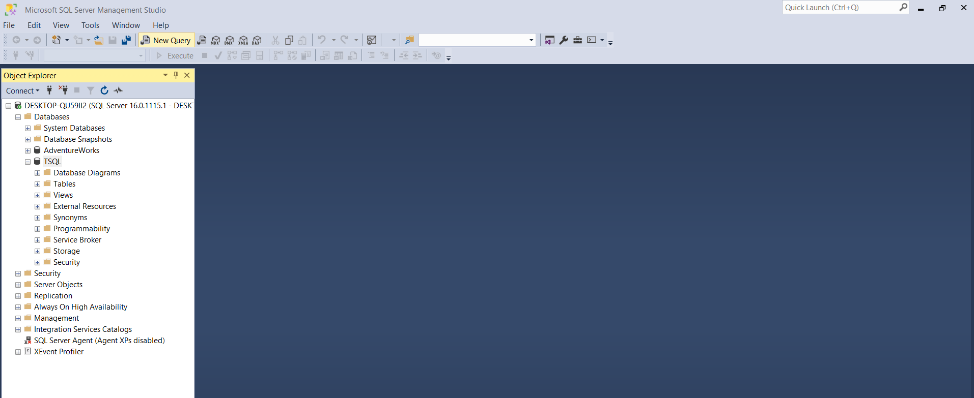

-Double-click on Databases/TSQL/Tables or on the ‘+’ in the left side of ‘Tables’

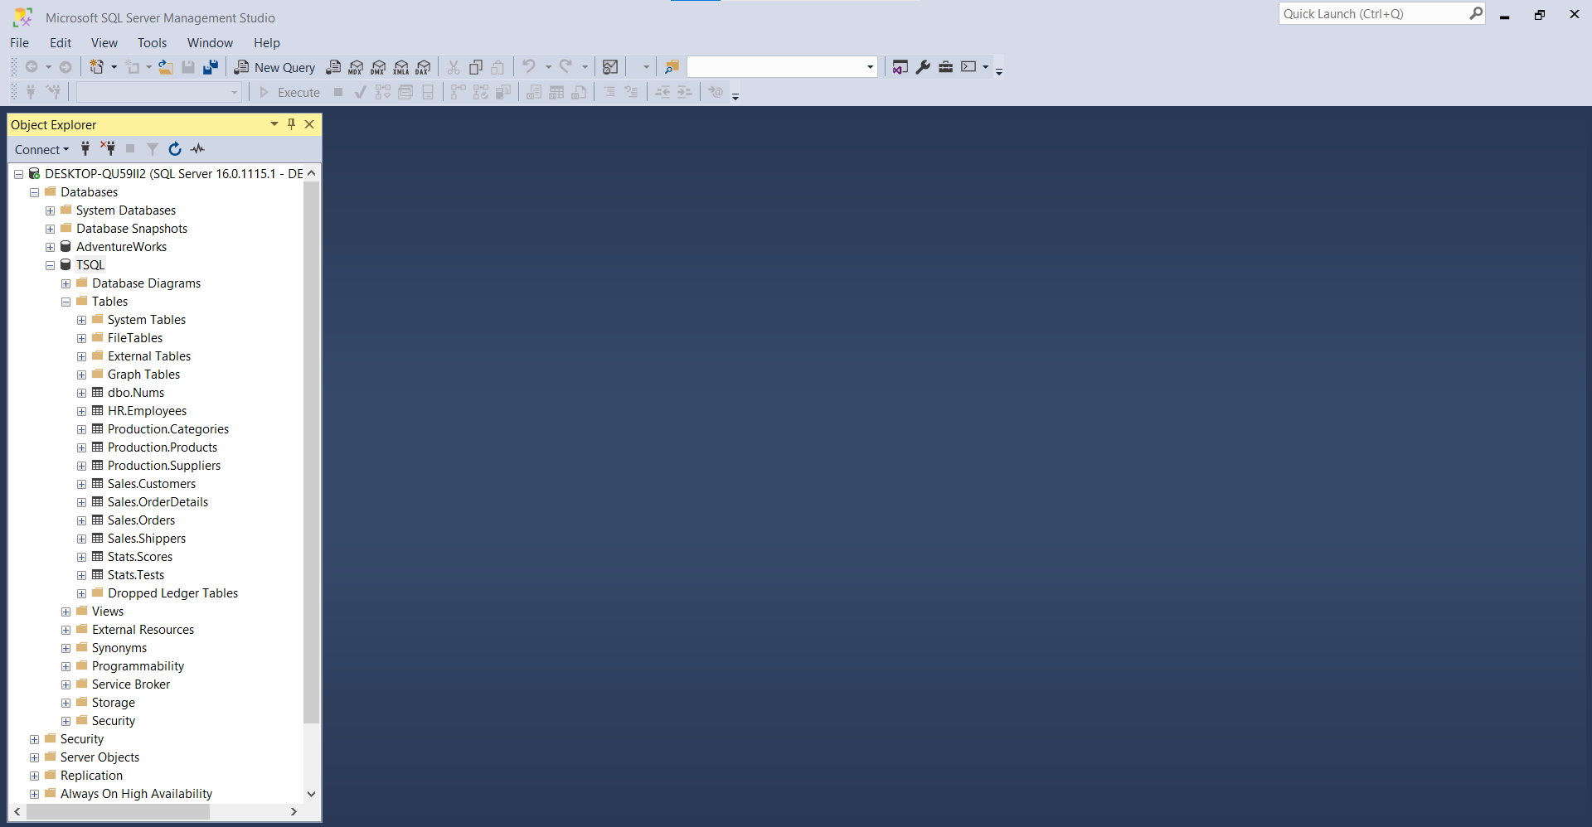

3-Tables on the Sales-schema

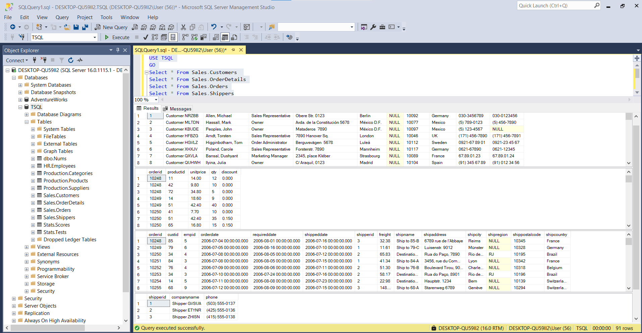

Tables of Sales-Schema

---------------------------------------------------------------------

-- Task 2

--

-- Write a SELECT statement that will return all rows and all columns from the Sales.Customers table.

-- Tip: You can use drag-and-drop functionality to drag items like table and column names from Object Explorer to the query window. Write the same SELECT statement using the drag-and-drop functionality.

--

-- Execute the written statement and compare the results that you got with the desired results shown in the file Lab Exercise 1 - Task 2 Result.txt.

---------------------------------------------------------------------

---------------------------------------------------------------------

-- Detyre 2

--

1-- Selektoni te gjitha rrjeshtat dhe kolonat nga tabela Sales.Customers.

-- Keshille : Mund te perdorni funksionalitetin drag-and-drop per te terhequr objektet si emrat e tabelave dhe emrat e kolonave nga Object Explorer ne dritaren e query. Shkruani te njejtat veprime duke perdorur funksionalitetin drag-and-drop.

--

2-- Ekzekutoni veprimet e mesiperme dhe krahasoni rezultatet qe ju moret me rezultatet e deshiruara ne dokumentin Lab Exercise 1 - Task 2 Result.txt.

---------------------------------------------------------------------

1-[Sales].[Customers]—(Nëpërmjet funksionalitetit Drag&Drop)

[custid], [companyname], [contactname], [contacttitle], [address], [city], [region], [postalcode], [country], [phone], [fax]

2-

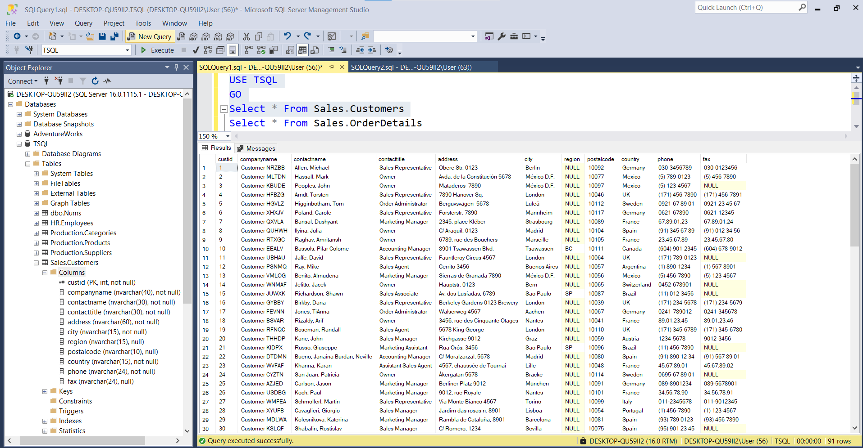

\*Si përfundim ,tabela me *atributet përkatëse* gjeneron rezultat të njëjtë \*me atributet e tabeles qe fitojme nese klikojme mbi ikonen ‘Columns’ të \*Sales.Customers

---------------------------------------------------------------------

-- Task 3

--

1-- Expand the Sales.Customers table in Object Explorer and expand the Columns folder. Observe all columns in the table.

--

2-- Write a SELECT statement to return the contactname , address, postalcode, city, and country columns.

--

3-- Execute the written statement and compare the results that you got with the desired results shown in the file Lab Exercise 1 - Task 3 Result.txt.

--

4-- What is the number of rows affected by the last query? (Tip: Because you are issuing a SELECT statement against the whole table, the number of rows will be the same as number of rows for the whole Sales.Customer table.)

---------------------------------------------------------------------

1—Expand the Column Folder in Sales.Customers table

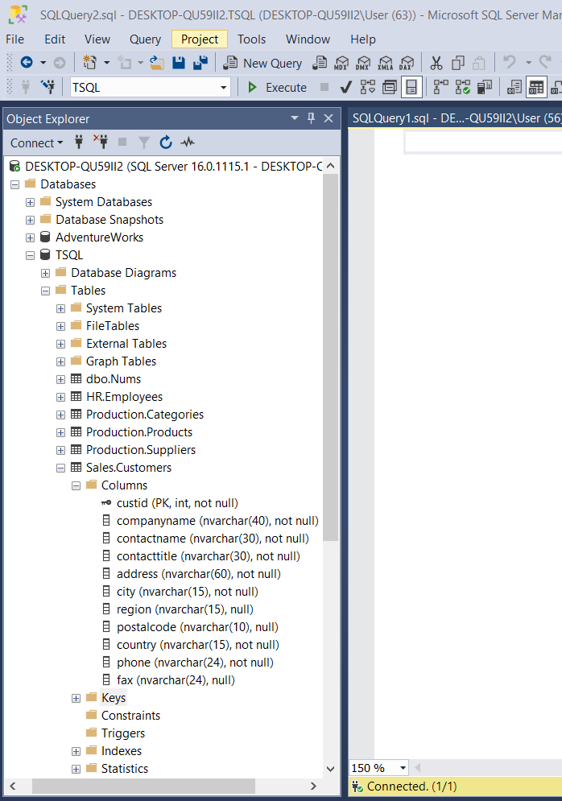

2—

USE TSQL

GO

Select sc.contactname, sc.address, sc.postalcode,sc.city,sc.country From Sales.Customers sc

ose

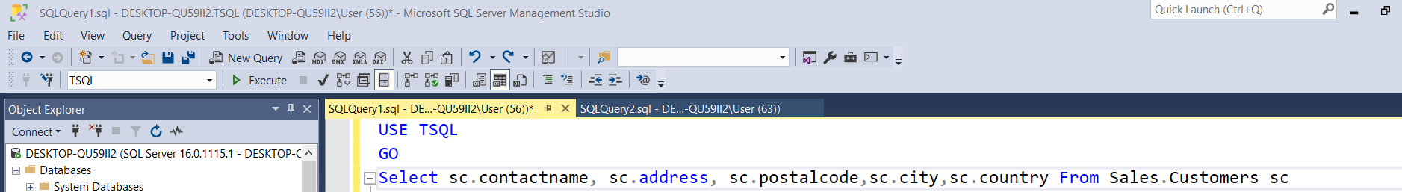

3—Generated result after execution of selected query

Rezultati i gjeneruar pas ekzekutimit të queries së selektuar

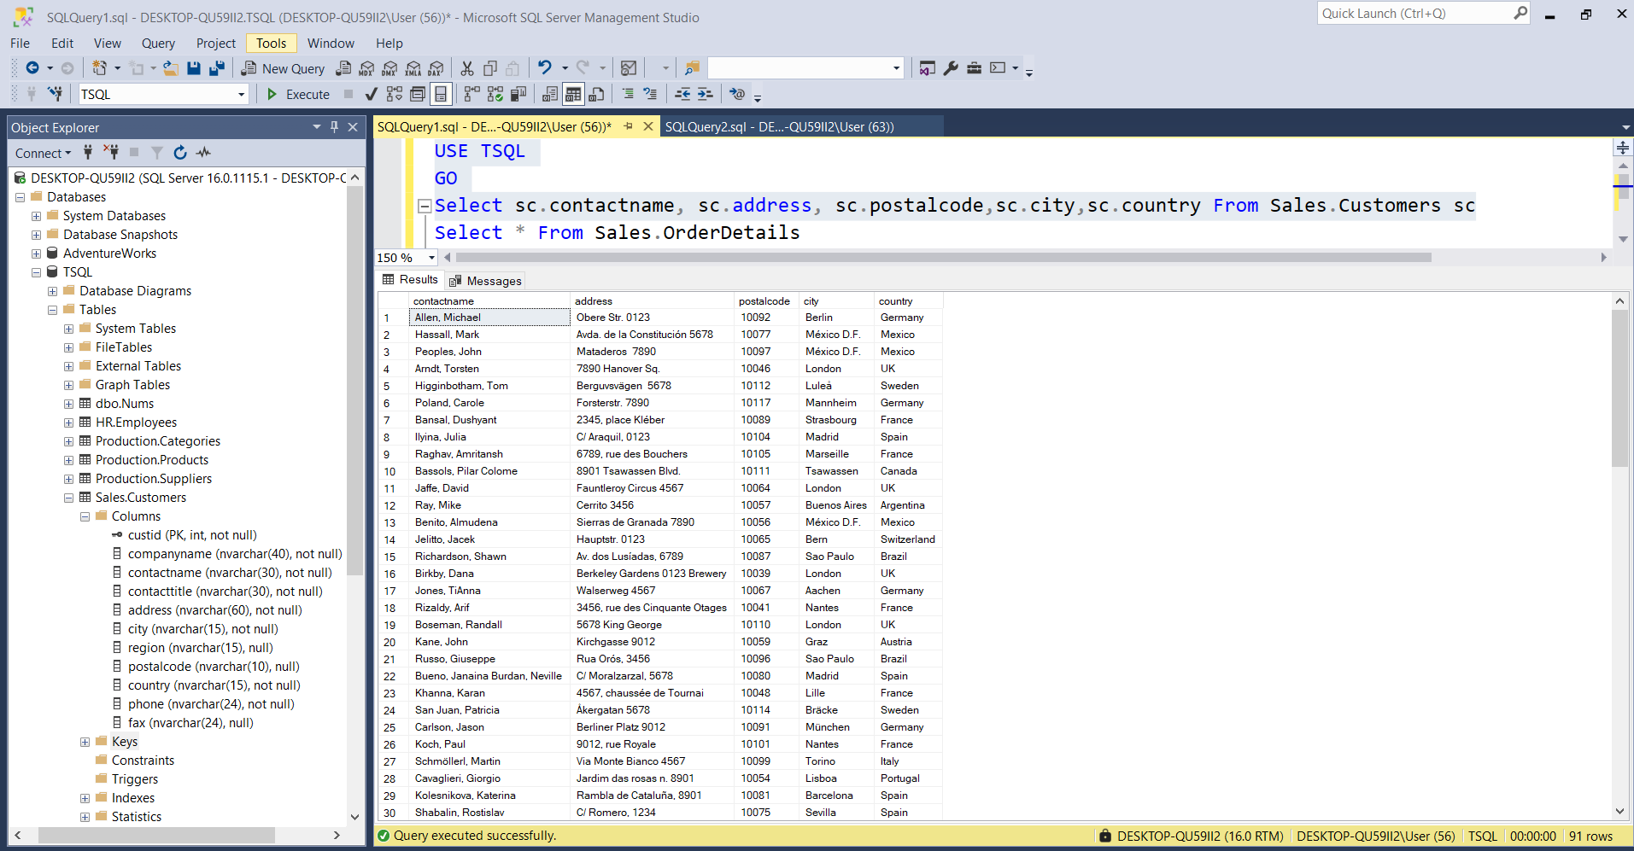

4—The number of affected rows by the last query is 91 rows that is the same number generated by the query executed on point 3,Task 3

